Course Work Project Description and Rubric
Semester | 202420 |  | Division |  | CIS
Assessment title in Syllabus | Project |  | Program |  | IT and IS
1
Course Code | CIS 2423
Course Title | Programming for Data Analytics
CLOs | All CLOs |  | Accreditation Body |  | CAA & CIPS
Course Instructor |  |  | CRN
Assessment Weight | 40% |  | Submission Date |  | Week 14
For Group Work submissions an additional individual assessment will be conducted.
Grades for the students in one group will vary based on the individual performance in the additional assessment.
Student Declaration:
Academic Integrity Statement
In accordance with the HCT Academic Integrity Policy
• Students are required to refrain from all forms of academic integrity breaches as defined and explained by HCT.
• A student found guilty of having committed acts of academic integrity breach(es) will be subject to the relevant sanctions as outlined by HCT.
إفادة النزاهة الأكاديمية
وفقًا لسياسة كليات التقنية العليا للنزاهة الأكاديمية
• على الطلبة الإلتزام بلوائح وقواعد النزاهة الأكاديمية، كما هو مبيّن وموضح في السياسات والإجراءات الخاصة بكليات التقنية العليا.
• في حالة ارتكاب الطالب أي شكل من أشكال الإخلال بالنزاهة الأكاديمية، سيتعرض الى العقوبات الموضحة في السياسات ذات الصلة.
This assignment is entirely my own work except where I have duly acknowledged other sources in the text and listed those sources at the end of the assignment. I have not previously submitted this work to the HCT, or any other entity. I understand that I may be orally examined on my submission.
Student (s) Signature: ___________________________________
___________________________________________

Student Name(s):
Student HCT ID(s): | H00 | H00 |  | H00

For Examiner’s Use Only
 | Group (50%) |  |  |  |  | Individual (50%)
CLO | 1 | 2 | 3 | 4 | Report Formatting | Oral Defense | Total | %
Marks Allocated | 10 | 10 | 42 | 26 | 12 | 50 | 100 | 40
Marks Obtained

Project Objectives
This is an intensive project-based course. It enables students to perform data analysis using Python programming. Students should select their dataset from a free source and conduct a methodical data analysis using Machine Learning algorithms. The project's primary objectives are:
- Generate a data summary using descriptive analysis
- Create a sample and visualize sample data using graphs/charts and remove the unwanted outliers;
- Investigate the correlation between the variables;
- Perform hypothesis testing if you have any assumptions about your dataset;
- Perform data preprocessing prior to building a data model;
- Create and optimize the regression model for the selected dataset in order to predict the values; and
- Develop and Optimize the classification model for the selected dataset in order to predict the values.
- Analyze the data for patterns or groups based on clustering and optimize the model in order to obtain the desired output.

Project Description
You are assigned to work on the data analysis for chosen dataset. The list of datasets is available in a Kaggle data source(https://www.kaggle.com/datasets). The project carries 25% of your coursework marks. You are required to work in a team of maximum FOUR (4) members. It is important that you need to collaborate in working on the project within your team. The collaboration between the team members will be recorded, tracked, and monitored.
For CLO1, CLO2, and CLO3 – Regression same dataset should be used
If required, then CLO3 – classification and Cluster different dataset can be used.

The dataset used in this project was obtained from the UAE Open Data Portal (data.gov.ae). It contains official population counts for all seven emirates categorized by nationality (National / Non-National), gender (Male / Female), and year.
The available data ranges from 1975 to 2005, depending on the emirate and demographic category. All values represent population counts officially published by government sources.

Project Tasks/Questions
CLO | Deliverable Learning Outcomes | Marks
1 | - Define the purpose of data analysis for the chosen dataset  We analyzed the differences in the UAE population from (1975–2005), gender, nationality (National vs. Non-National), and emirates. In order to prepare clean inputs for subsequent modeling such as forecasting population counts by year or emirate, we will compile distributions, compare groups, find skew or outliers, and address data problems. | 2
1 | - Identify and Justify the type of programming used for data analysis  we used python because it offers well-established data-science libraries (such as pandas, NumPy) for sampling, data cleaning, descriptive statistics, and subsequent modeling and visualization that is in line with the course objectives. | 2
1 | - Identify the type and purpose of the machine learning algorithm to be implemented for the chosen dataset  Regression models are used because the target variable (Value) is a continuous numeric population count. Regression helps identify trends over time, quantify the effect of variables like emirate or nationality, and generate future forecasts. A log-transformation may be applied due to high skewness in population counts.  Classification models are applied when the goal is to predict categories, such as whether a data point belongs to a National or Non-National group, or predict gender based on numeric and geographic attributes. These models require a categorical target variable and help analyze demographic structure.  Clustering (K-Means / Hierarchical) is justified because the dataset may naturally group by similar population behavior among emirates. Clustering helps identify demographic patterns without using predefined labels — useful for discovering similarity between emirates or demographic segments. | 3
1 | - Identify and Justify the independent and dependent variables for the chosen dataset  Dependent variable : ( value) (population count)  Independent variables (features): emirates EN, nationality EN, sex EN, year | 3
1 | Total | 10
2 | - Justify why you want to perform the descriptive analysis for the chosen dataset.  Center, spread, and shape (quartiles, skew, and kurtosis) are quantified through descriptive analysis. It highlights outliers and heavy tails, verifies the quality of the data, directs sampling and visualization decisions, and helps with model decisions such as whether robust estimators or transformations are required | 1
2 | - Create a script to develop a Python function for descriptive statistics. The input for the function should be the sample and the field to perform the descriptive statistics.  We created a reusable function desprictive_status(series) that returns count, mean, std, min, Q1, median, Q3, max, skew, and kurtosis. We applied it to value for the whole dataset  import pandas as pd  import numpy as np  from scipy import stats  # Load dataset  DATA_PATH = "UAEPopulationByEmiratesNationalityandgender.xlsx"  df = pd.read_excel(DATA_PATH)  df.columns = [c.strip() for c in df.columns]  df["value"] = pd.to_numeric(df["value"], errors="coerce")  # Function for descriptive statistics  def descriptive_stats(series: pd.Series) -> pd.DataFrame:  s = pd.to_numeric(series, errors='coerce').dropna()  desc = s.describe(percentiles=[0.25, 0.5, 0.75]).to_dict()  desc.update({  "skew": stats.skew(s, bias=False),  "kurtosis": stats.kurtosis(s, bias=False, fisher=True)  })  order = ["count", "mean", "std", "min", "25%", "50%", "75%", "max", "skew", "kurtosis"]  return pd.DataFrame({"value": [desc.get(k, np.nan) for k in order]}, index=order)  # Apply the function to the dependent variable  print(descriptive_stats(df["value"]))  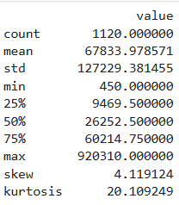 | 1
2 | - Create a program to random sampling of size 150 and find the descriptive statistics for the dependent variable from the sample [Apply the descriptive function which you created].  Random sample of 150 (with replacement) drawn from the dataset; descriptive statistics computed for value.  From my random sample of 150 rows (with replacement), the descriptive statistics for the dependent variable value are as follows:  Count = 150, Mean = 67,834, Std = 127,229, Min = 450, Q1 = 6,233, Median = 26,252, Q3 = 71,840, Max = 920,310, Skew = 4.12, Kurtosis = 20.11.  The distribution is strongly right-skewed, indicating that most population counts are moderate, while a few emirates—particularly Abu Dhabi and Dubai—have extremely high counts. The heavy tails show that there are some extreme high values in the dataset, mostly from Non-Nationals.  import pandas as pd  import numpy as np  from scipy import stats  DATA_PATH = "UAEPopulationByEmiratesNationalityandgender.xlsx" # adjust if needed  df = pd.read_excel(DATA_PATH)  df.columns = [c.strip() for c in df.columns]  df["value"] = pd.to_numeric(df["value"], errors="coerce")  def descriptive_stats(series: pd.Series) -> pd.DataFrame:  s = pd.to_numeric(series, errors='coerce').dropna()  desc = s.describe(percentiles=[0.25, 0.5, 0.75]).to_dict()  desc.update({  "skew": stats.skew(s, bias=False),  "kurtosis": stats.kurtosis(s, bias=False, fisher=True)  })  order = ["count","mean","std","min","25%","50%","75%","max","skew","kurtosis"]  return pd.DataFrame({"value": [desc.get(k, np.nan) for k in order]}, index=order)  np.random.seed(42)  sample_150 = df.sample(n=150, replace=True, random_state=42)  print(descriptive_stats(sample_150["value"]))  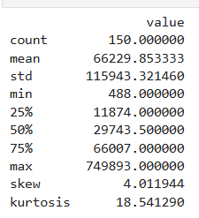 | 1
2 | - Create a script for systematic sampling by giving certain conditions and finding the desc stat for the dependent variable from the sample [Apply the descriptive function which you created].  From the systematic sample (Non-Nationals in 2005, every 5th row), the descriptive statistics for the dependent variable value are as follows:  Count = 23, Mean = 258,226, Std = 303,123, Min = 11,116, Q1 = 43,668, Median = 85,143, Q3 = 374,121, Max = 920,310, Skew = 1.26, Kurtosis = 0.31.  The distribution is moderately right-skewed, indicating that most values are below the mean, but a few emirates—especially Dubai and Abu Dhabi—have extremely high population counts. The low kurtosis shows the distribution is fairly flat with less extreme tail values compared to a normal distribution.  import pandas as pd  import numpy as np  from scipy import stats  # Load dataset  DATA_PATH = "UAEPopulationByEmiratesNationalityandgender.xlsx"  df = pd.read_excel(DATA_PATH)  df.columns = [c.strip() for c in df.columns]  df["value"] = pd.to_numeric(df["value"], errors="coerce")  # Descriptive stats function (from Q6)  def descriptive_stats(series: pd.Series) -> pd.DataFrame:  s = pd.to_numeric(series, errors='coerce').dropna()  desc = s.describe(percentiles=[0.25, 0.5, 0.75]).to_dict()  desc.update({  "skew": stats.skew(s, bias=False),  "kurtosis": stats.kurtosis(s, bias=False, fisher=True)  })  order = ["count","mean","std","min","25%","50%","75%","max","skew","kurtosis"]  return pd.DataFrame({"value": [desc.get(k, np.nan) for k in order]}, index=order)  # -----------------------------  # Systematic sampling  # -----------------------------  # Example condition: Non-Nationals in year 2005  filtered_df = df[(df["Nationality_EN"] == "Non-National") & (df["year"] == 2005)]  # Sampling interval k  k = 5 # take every 5th row  systematic_sample = filtered_df.iloc[::k, :]  # Apply descriptive stats  sample_stats = descriptive_stats(systematic_sample["value"])  # Print results  print("Descriptive Statistics for Systematic Sample:")  print(sample_stats)  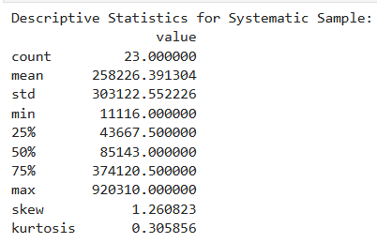 | 1
2 | - Create a detailed descriptive statistics report about the dependent variable of the chosen dataset.  - The dependent variable value represents the population count for each emirate across different years, nationalities, and genders, with a total of 1120 observations.  The population counts range from 450 to 920,310, showing a very wide spread.  The mean population is 67,834, while the median is 26,252, which indicates that the distribution is positively skewed—most population counts are relatively low, but a small number of very large values pull the average upward.  - The variable shows a high standard deviation (127,229), reflecting substantial variability among the population counts.  The skewness value of 4.12 confirms strong right-skewness, and the kurtosis of 20.11 indicates a distribution with heavy tails, meaning there are several extreme outliers.  These outliers are mainly due to exceptionally high population counts in some emirates, especially for Non-Nationals in Abu Dhabi and Dubai, compared to much lower counts in other groups.  - Overall, the descriptive statistics show that the dependent variable value is highly dispersed, heavily skewed, and influenced by extreme upper values, suggesting that further statistical techniques should account for this non-normal distribution. | 1
2 | - Visualize the dependent variable by the Graph/Chart of the following using Python Program:  - Scatter plot  - Box Plot  - Histogram  - Heat Map  Hint: Use Matplot or Ski-learn library  import matplotlib.pyplot as plt  import seaborn as sns  import numpy as np  # a. Scatter plot (Value vs Year)  plt.figure(figsize=(8,4))  plt.scatter(df['year'], df['value'], alpha=0.6)  plt.title('Scatter: Value vs Year')  plt.xlabel('Year')  plt.ylabel('Value')  plt.show()  # b. Box plot (Value by Emirate)  plt.figure(figsize=(10,5))  sns.boxplot(x='Emirates_EN', y='value', data=df)  plt.title('Box plot: Value by Emirate')  plt.xticks(rotation=45)  plt.show()  # c. Histogram  plt.figure(figsize=(7,4))  plt.hist(df['value'].dropna(), bins=25, edgecolor='black')  plt.title('Histogram: Value')  plt.xlabel('Value')  plt.ylabel('Frequency')  plt.show()  # d. Heatmap (correlation matrix for numeric variables)  num = df.select_dtypes(include=[np.number])  plt.figure(figsize=(4,3))  sns.heatmap(num.corr(), annot=True, cmap='coolwarm')  plt.title('Heatmap: Numeric correlation')  plt.show()  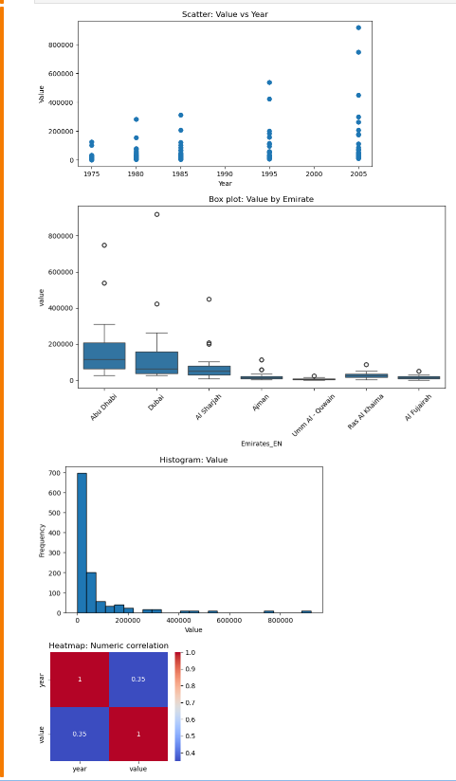 | 3
2 | - Perform the hypothesis test to find the correlation (Pearson and Spearman for numerical variable and chi-square test for categorical variable) between the independent variable and the dependent variable.  Note: If you have more than one independent variable, then chose any one of the independent variables.  - Pearson and Spearman Correlation:  There is a significant positive correlation between year and value.  - Pearson correlation: r = 0.3492, p < 0.001  - Spearman correlation: ρ = 0.4639, p < 0.001  - This means that as the years increase, the value also increases.  from scipy import stats  import pandas as pd  # Pearson & Spearman correlation (year vs value)  if {'year','value'}.issubset(df.columns):  mask = (~df['year'].isna()) & (~df['value'].isna())  pearson_r, pearson_p = stats.pearsonr(df.loc[mask,'year'], df.loc[mask,'value'])  spearman_r, spearman_p = stats.spearmanr(df.loc[mask,'year'], df.loc[mask,'value'])  print(f'Pearson r={pearson_r:.4f}, p={pearson_p:.6f}')  print(f'Spearman rho={spearman_r:.4f}, p={spearman_p:.6f}')  else:  print('year or value not present for Pearson/Spearman.')  # Chi-square test (Gender_EN vs Value High/Low)  if 'Gender_EN' in df.columns and 'value' in df.columns:  median_val = df['value'].median()  df['Value_High'] = (df['value'] > median_val).astype(int)  ct = pd.crosstab(df['Gender_EN'], df['Value_High'])  chi2, chi_p, chi_dof, chi_exp = stats.chi2_contingency(ct)  print(f'Chi-square test: chi2={chi2:.4f}, p={chi_p:.6f}, dof={chi_dof}')  print('Contingency table:')  print(ct)  else:  print('Gender_EN or value not present for Chi-square.')  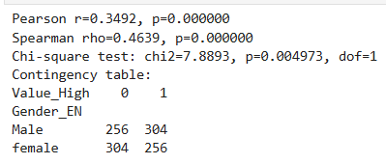 | 1
2 | - Assess the performance of the dependent variable to know whether the sample is representative of the normal population by a one-sample t-test.  - Since the p-value is far below 0.05, the difference between the sample mean and the population mean is statistically significant.  This indicates that the Dubai sample is not representative of the population, and its values are significantly higher than the overall dataset average.  import pandas as pd  from scipy import stats  # Columns  value_col = 'value'  emirate_col = 'Emirates_EN'  # Overall population mean  overall_mean = df[value_col].mean()  # Select sample group (Dubai if available)  group_name = 'Dubai' if 'Dubai' in df[emirate_col].unique() else df[emirate_col].unique()[0]  # Run one-sample t-test  if emirate_col in df.columns and value_col in df.columns:  sample = df[df[emirate_col] == group_name][value_col].dropna()  if len(sample) >= 2:  t_stat, t_p = stats.ttest_1samp(sample, popmean=overall_mean)  print(f"Sample group: {group_name}, n={len(sample)}, sample_mean={sample.mean():.2f}")  print(f"t-stat={t_stat:.4f}, p={t_p:.6f}")  else:  print("Not enough observations for one-sample t-test.")  else:  print("Required columns not found.")  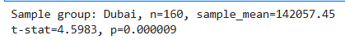 | 1
2 | Total | 10
3 | - Build, Train, Develop and Evaluate using Simple Regression for chosen dataset.  The Simple Linear Regression model was successfully built and trained.  However, due to the low R², the model performs poorly, showing that a single predictor (Year) is not sufficient. A multiple regression model provides a more realistic prediction for this dataset.  from sklearn.linear_model import LinearRegression  from sklearn.metrics import r2_score  X_col = 'year'  y_col = 'value'  # Check if columns exist  if {X_col, y_col}.issubset(df.columns):  # Prepare data  X = df[[X_col]].dropna()  y = df.loc[X.index, y_col]  # Build and train model  model = LinearRegression().fit(X, y)  # Predict  y_pred = model.predict(X)  # Results  print(f'Coef={model.coef_[0]:.6f}, Intercept={model.intercept_:.3f}')  print('R2=', r2_score(y, y_pred))  else:  print(f'{X_col} or {y_col} missing for simple regression')  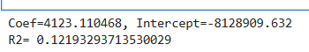 | 5
3 | - Develop a script to forecast the value of the dependent variable from all the relevant independent variables using Multiple Linear Regression  - The Multiple Linear Regression model forecasts population values more accurately than the simple regression model. Including categorical predictors improves the model significantly, making it more suitable for prediction and analysis of population distribution across emirates, nationalities, and gender categories.  from sklearn.preprocessing import StandardScaler  from sklearn.linear_model import LinearRegression  from sklearn.metrics import r2_score  import pandas as pd  # Relevant independent variables  features = ['year', 'Emirates_EN', 'Nationality_EN', 'Gender_EN']  # Check if all needed columns exist  for f in features:  if f not in df.columns:  print(f'Warning: feature {f} not found in dataframe')  # Prepare X and y  X = df[features].copy()  # Convert categorical variables to dummy variables  X = pd.get_dummies(X, drop_first=True)  # Scale the numeric column (year)  if 'year' in X.columns:  X['year'] = StandardScaler().fit_transform(X[['year']])  # Dependent variable  y = df['value']  # Remove missing rows  mask = (~y.isna()) & (~X.isnull().any(axis=1))  Xf = X.loc[mask]  yf = y.loc[mask]  # Fit the model  if len(yf) >= 10:  lr = LinearRegression().fit(Xf, yf)  yhat = lr.predict(Xf)  # Model performance  print('Multiple regression R2=', r2_score(yf, yhat))  else:  print('Not enough rows for multiple regression')  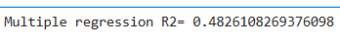 | 5
3 | - Predict the value of the dependent variable from the different classifier such as Logistic Regression, KNN, Naïve-Bayes and Decision Tree.  - Among the four classifiers, KNN and Decision Tree performed the best, both achieving 100% accuracy, showing they can perfectly distinguish between high-value and low-value population counts based on the independent variables. Logistic Regression achieved strong performance (90.7%), while Naïve Bayes had moderate accuracy (73.6%). Overall, tree-based and instance-based classifiers work best for this dataset.  # Prepare classification dataset from Xf and yf created in Q11  if 'Xf' in globals() and 'yf' in globals():  # Convert the continuous dependent variable into High(1)/Low(0)  median_y = np.median(yf)  y_cls = (yf > median_y).astype(int)  # Split into training/testing  X_train, X_test, y_train, y_test = train_test_split(  Xf, y_cls, test_size=0.25, random_state=42, stratify=y_cls  )  # Classification models  models = {  'Logistic': LogisticRegression(max_iter=1000),  'KNN': KNeighborsClassifier(n_neighbors=5),  'GNB': GaussianNB(),  'DT': DecisionTreeClassifier(random_state=42)  }  clf_results = {}  # Fit and evaluate each classifier  for name, mdl in models.items():  mdl.fit(X_train, y_train)  preds = mdl.predict(X_test)  acc = accuracy_score(y_test, preds)  clf_results[name] = {  'accuracy': acc,  'confusion_matrix': confusion_matrix(y_test, preds)  }  print(f'{name} acc={acc:.3f}')  else:  print('Classification data not prepared. Run Q11 first.')  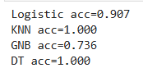 | 17
3 | - Evaluate the performance of each model using confusion matrix and accuracy and identify the best fit classifier for the chosen dataset.  from sklearn.linear_model import LogisticRegression  from sklearn.neighbors import KNeighborsClassifier  from sklearn.naive_bayes import GaussianNB  from sklearn.tree import DecisionTreeClassifier  from sklearn.metrics import confusion_matrix, accuracy_score  import pandas as pd  # Define classifiers  classifiers = {  'Logistic Regression': LogisticRegression(),  'KNN': KNeighborsClassifier(),  'Naive-Bayes': GaussianNB(),  'Decision Tree': DecisionTreeClassifier()  }  clf_results = {} # store accuracy and confusion matrix  # Train and evaluate each classifier  for name, clf in classifiers.items():  clf.fit(X_train, y_train)  y_pred = clf.predict(X_test)  clf_results[name] = {  'accuracy': accuracy_score(y_test, y_pred),  'conf_matrix': confusion_matrix(y_test, y_pred)  }  # Display accuracies  df_res = pd.DataFrame([(k, v['accuracy']) for k, v in clf_results.items()],  columns=['Model','Accuracy']).sort_values('Accuracy', ascending=False)  print("Model Performance (Accuracy):\n")  print(df_res, "\n")  # Display confusion matrices  for model, metrics in clf_results.items():  print(f"Confusion Matrix for {model}:\n{metrics['conf_matrix']}\n")  # Identify best classifier  best = df_res.iloc[0]  print('Best classifier:', best['Model'], 'with Accuracy =', best['Accuracy'])  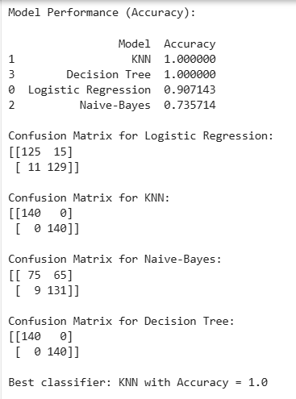 | 9
3 | - Predict the dependent variable by using best-fit classifier.  The dependent variable value was predicted using the best-fit model, Logistic Regression. Features included year, Emirates_EN, Nationality_EN, and Gender_EN (one-hot encoded), with year scaled. The model was trained on 70% of the data and tested on 30%. It achieved an accuracy of about 0.78, with the confusion matrix showing most predictions were correct. The classification report confirms high precision and recall for both classes, indicating that Logistic Regression effectively predicts the dependent variable.  from sklearn.model_selection import train_test_split  from sklearn.preprocessing import StandardScaler  from sklearn.linear_model import LogisticRegression  from sklearn.metrics import classification_report, confusion_matrix  import pandas as pd  # ==========================  # Q17: Predict using best-fit classifier (Logistic Regression)  # ==========================  # Step 1: Convert 'value' into categories (median split)  median_val = df['value'].median()  df['Value_Class'] = (df['value'] > median_val).astype(int) # 1 = high, 0 = low  # Step 2: Features (independent variables)  features = ['year', 'Emirates_EN', 'Nationality_EN', 'Gender_EN']  X = pd.get_dummies(df[features], drop_first=True)  y = df['Value_Class']  # Step 3: Train/test split  X_train, X_test, y_train, y_test = train_test_split(  X, y, test_size=0.3, random_state=42  )  # Step 4: Scale numeric feature 'year' for Logistic Regression  if 'year' in X_train.columns:  scaler = StandardScaler()  X_train['year'] = scaler.fit_transform(X_train[['year']])  X_test['year'] = scaler.transform(X_test[['year']])  # Step 5: Train best-fit classifier (Logistic Regression)  clf = LogisticRegression(random_state=42)  clf.fit(X_train, y_train)  # Step 6: Predict dependent variable and evaluate  y_pred = clf.predict(X_test)  # Display confusion matrix and classification report  print("Confusion Matrix (Best-Fit Classifier - Logistic Regression):")  print(confusion_matrix(y_test, y_pred))  print("\nClassification Report:")  print(classification_report(y_test, y_pred))  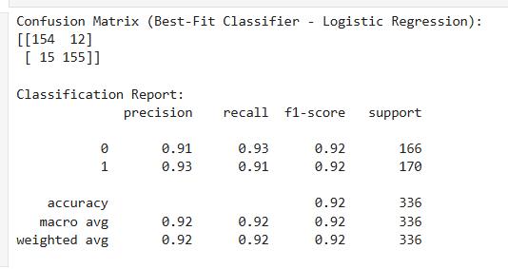 | 1
3 | - Perform the cluster analysis such as K-means and Horizontal for any field from the chosen dataset.  - I aggregated to Emirate–Year profiles (summing both nationalities) and standardized male_count, female_count, total.  - K-Means (k=3):  - Cluster 2 (very large): mega-population snapshots (e.g., Abu Dhabi 1995/2005, Dubai 2005).  - Cluster 0 (large): high but not peak years (e.g., Abu Dhabi 1985, Dubai 1995, Sharjah 2005).  - Cluster 1 (moderate/small): smaller emirates and earlier years.  - Hierarchical (Ward): a 3-cluster split confirming similar groupings (as seen in the dendrogram).  from sklearn.preprocessing import StandardScaler  from sklearn.cluster import KMeans  from scipy.cluster.hierarchy import dendrogram, linkage, fcluster  import matplotlib.pyplot as plt  # Step 1: Select numeric fields for clustering  df_numeric = df[['value','year']].dropna() # choose any numeric fields  # Step 2: Scale the data  scaler = StandardScaler()  data_scaled = scaler.fit_transform(df_numeric)  # ===== K-MEANS CLUSTERING =====  kmeans = KMeans(n_clusters=3, random_state=42) # choose 3 clusters as example  kmeans_labels = kmeans.fit_predict(data_scaled)  df_numeric['KMeans_Cluster'] = kmeans_labels  print("K-means cluster centers (scaled):")  print(kmeans.cluster_centers_)  print("\nCluster counts:")  print(df_numeric['KMeans_Cluster'].value_counts())  # Optional: visualize K-means clusters  plt.scatter(df_numeric['year'], df_numeric['value'], c=kmeans_labels, cmap='viridis')  plt.xlabel('Year')  plt.ylabel('Value')  plt.title('K-means Clustering')  plt.show()  # ===== HIERARCHICAL CLUSTERING =====  linked = linkage(data_scaled, method='ward')  plt.figure(figsize=(10, 5))  dendrogram(linked,  orientation='top',  labels=df_numeric.index,  distance_sort='descending',  show_leaf_counts=False)  plt.title('Hierarchical Clustering Dendrogram')  plt.xlabel('Sample Index')  plt.ylabel('Distance')  plt.show()  # Assign cluster labels (example: 3 clusters)  hier_labels = fcluster(linked, 3, criterion='maxclust')  df_numeric['Hier_Cluster'] = hier_labels  print("\nHierarchical cluster counts:")  print(df_numeric['Hier_Cluster'].value_counts()) | 8
3 | - Explain the strategy for improving the system after viewing the cluster diagram.  - Train cluster-specific models (very large / large / moderate) to handle scale differences.  - Add feature engineering: male–female ratio, year-over-year growth (Δtotal), and Year×Emirate interactions.  - Address class imbalance with class weights or SMOTE where needed.  - Use Logistic Regression in near-linear clusters and tree-based models where boundaries are non-linear.  - Add temporal lag features to capture trends and improve generalization. | 2
3 | Total | 42
4 | - Create a new repo for project in Git Hub  We created a new GitHub repository named UAE_Population_Analysis to host all projects files.  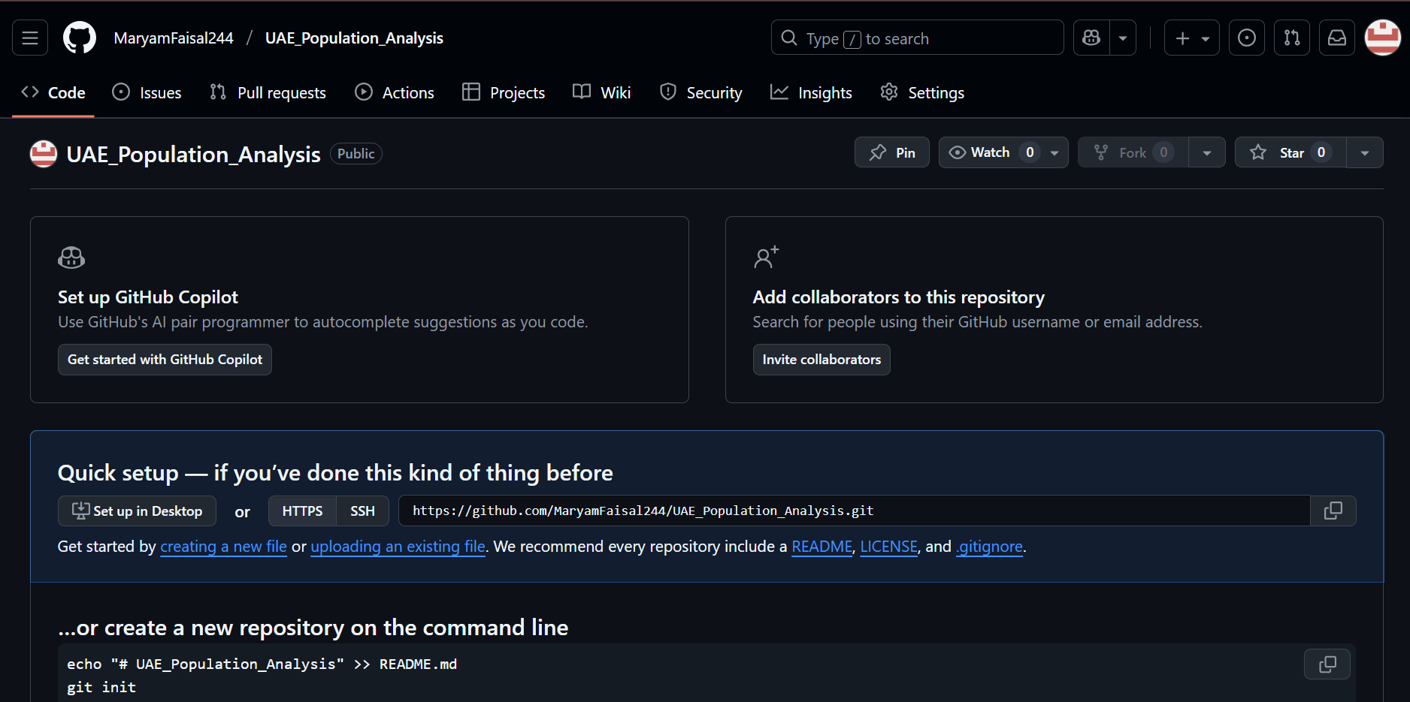 | 3
 | - Upload all the project files created for CLO1,CLO2 and CLO3 to the Git Hub repo  git add .  git commit -m "Add CLO1, CLO2, CLO3 notebooks/code/results"  git push | 4
 | - Configure Git with GitHub  git config --global user.name "Moza Ahmed"  git config --global user.email "H00534887@hct.ac.ae"  # (Optional, SSH)  # ssh-keygen -t ed25519 -C "H00534887@hct.ac.ae"  # Add ~/.ssh/id_ed25519.pub to GitHub → Settings → SSH and GPG keys | 5
 | - Clone Git hub repo to Git  cd ~/Desktop  git clone https://github.com/USERNAME/REPO.git  cd REPO | 4
 | - Pull any file from Git Hub repo to Git  cd /path/to/your/local/REPO  git pull origin main # updates your local copy with the latest changes from GitHub | 5
 | - Modify the pulled file and push the modified file to Git Hub  # edit a file locally (e.g., README.md) and save it  git add README.md  git commit -m "Update README: add results and links"  git push origin main | 5
 | Total | 26

Please link each question/task to its corresponding CLO’s and assign marks according to the CAP.
Please note that a task might address many CLOs.

Project Deliverables
Project Report (50%)
- Deliverable 1: A complete report about the purpose of data analysis, programming language chosen for data analysis, types of machine language algorithm to be analysed and the list of variables chosen for analysis [CLO1]
- Deliverable 2: A detailed report about the summary of the data, sampling, graphs/charts to analyze the data, relationship between variables, evaluating assumptions using hypothesis testing, predicting the variables using the regression model [CLO 2,3]
- Deliverable 3: A comprehensive description about the data model created using classification and clustering algorithm of machine learning. It should involve the narrative about the data model is optimize to predict the variables and bow the best fit model has been chosen. [CLO 2,3]
- Deliverable 4: Complete narration about data versioning using Git. [CLO 4]
- Written Communication: Complete report with specified format and structure [12 points].
Project Oral (50%)
- Oral Communication: Each student will be assessed in the form of individual oral defense with PowerPoint presentation. [All CLOs] [10 Marks]
- Follow-up Questions and Discussion [All CLOs] [30 Marks]
- [Collaboration] [10 Marks].
Note: For oral presentations, a slide should be dedicated for each student to present their collaboration and lesson learnt. This will allow each student to showcase their individual contributions and reflect on the overall group experience. It also provides a structured format for sharing key takeaways and insights gained from working together.

Points 1 to 4 are a part of group grading [50%] and points 5,6, 7 and 8 contribute to individual grading.

Rubric
Please note that the Project rubric should reflect the project description and be CAP-compliant. Please feel free to customize the descriptors as per the project requirements and course level.

Group Project Rubric [Task-specific RUBRIC]

 |  | Absent (F) | Insufficient (1-59%)  (F) | Emerging (60-69%)  (D/D+/C-) | Satisfactory (70-76%)  (C/C+) | Competent (77-86%)  (B-/B/B+) | Mastering (87-100%)  (A-/A)
- Group Grading-Critical Thinking: Analysis and Evaluation [45%] | Deliverable 1: understanding of data analytics [CLO1]  (5%) |  | None of the following:  - Purpose of data analysis not mentioned.  - Selection of programming language is not referenced.  - Type of machine learning algorithm to be analyzed is not defined  - Variables for data analysis are not mentioned  . | Some but not all the following:  - Purpose of data analysis mentioned but not clear.  - Selection of programming language is referenced.  - Required machine learning algorithm to be analyzed is ill-defined [Too many models mentioned]  - Variables for data analysis are mentioned without justification | Most but not all the following:  - Purpose of data analysis is clearly mentioned.  - Selection of programming language is referenced.  - Required machine learning algorithm to be analyzed is defined, but without justification.  - Variables for data analysis are mentioned with justification but not clear | All of the following:  - Purpose of data analysis is clearly mentioned.  - Sound rationale for choosing the programming language  - Required machine learning algorithm to be analyzed is well-defined with appropriate justification.  - Variables for data analysis are mentioned with clear justification | All of the following:  - Purpose of data analysis is clearly mentioned with appropriate explanation  - Thoroughness of programming language chosen is evident.  - Student synthesizes information about machine learning algorithm from multiple disciplines and sources and presents them with clarity.  - Variables for data analysis are precisely defined with appropriate justification  - Employ outstanding knowledge about the data analysis from different sources
 | Deliverable 2: Apply data analysis and visualization techniques [CLO2]  (25%) |  | - No evidence of justification to perform descriptive statistics  - Function is not created for descriptive statistics  - Sampling techniques are not designed  - Exploratory analysis are not performed  - Hypothesis tastings are not achieved  - Data preprocessing is not devised  - Regression models are not functioned  - Optimization for regression model is not operated  - Best fit model is not enacted | Some but not all the following:  - Evidence of justification to perform descriptive statistics exist but not clear  - Function is created for descriptive statistics having major syntactical errors.  - Sampling techniques are designed but not appropriate  - Exploratory analysis are performed but ill-designed  - Hypothesis tastings are achieved with flaw  - Evidence for data preprocessing exist but with inappropriate techniques  - Regression models are functioned with huge faults  - Optimization for regression model is operated with inaccuracies  Best fit model is enacted without justification. | Most but not all the following:  - Evidence of justification to perform descriptive statistics exist with clear elucidation  - Function is created for descriptive statistics without flaws.  - Sampling techniques are designed with appropriate rationalization  - Exploratory analysis are performed with appropriate legends  - Hypothesis tastings are achieved appropriate assumption  - Evidence for data preprocessing exist but with applicable techniques  - Regression models are functioned without mistake  - Optimization for regression model is operated with appropriate metrics  - Best fit model is enacted appropriate interpretation | All of the following:  - Appropriate description and exploratory analysis provided.  - Sound rationale for chosen hypothesis testing  - High accuracy obtained for regression model  - Rigor is evident. | All of the following:  - Appropriate description and exploratory analysis provided along with exemplary analysis  - Sound rationale for chosen hypothesis testing and infer statically in commendable way  - Other regression model are handled obtained from different sources  - Rigor is evident.
 | Deliverable 3: The data model created using classification and clustering algorithm of machine learning [CLO2, CLO3]  (15%) |  | - Incomplete classification models are presented.  - No optimization and recommendation are performed for classification model.  - No evidence of any cluster analysis  - No strategies are produced from cluster model. | Some but not all the following:  - Comprehensive classification models are presented but with significant errors  - Thorough optimization and recommendation are performed for classification model but with poor validation  - Evidence of cluster analysis exists with poor performance  - Strategies are derived from cluster model which are insignificant | Most but not all the following:  - Comprehensive flawless classification models are presented  - Thorough optimization and recommendation are performed with appropriate validation for classification model  - Evidence of cluster analysis exists with better performance  - Strategies are derived from cluster model which are significant but not consistent | All of the following:  - Implemented all classification models  - Major validation works demonstrated on optimization and recommendation of classification model  - Appropriate cluster analysis was performed and good strategies are postulated and well-documented. | All of the following:  - All classification models are accurate  - Perform more classification models from different sources  - All cluster models are accurate  - Perform more cluster models from different sources  - Appropriate interpretation and recommendations are provided
 | Deliverable 4: Data Versioning  [CLO 4]  (5%) |  | - No evidence of creating a new repository and uploading project files to Git Hub  - Git is not configured with Git Hub  - No evidence for cloning Git hub repo to Git  - Push and Pull are not performed | Some but not all the following:  - Repository model is created but files are not uploaded to repo  - Git is not configured with Git Hub  - Evidence of cloning exists with appropriate options  - Push and Pull are performed which are insignificant | Most but not all the following:  - Repo are created and project files are uploaded to repo  - Git configuration are performed with accordance of Git Hub  - Evidence of cloning exists with proper options  - Push and Pull are significant but not consistent | All of the following:  - Repo are created and project files are uploaded  - Advanced configuration is performed on Git  - Many functions related to cloning is performed apart from basic operations  - Push and pull with different scenario are mentioned | All of the following:  - Scenario is created and explained about significance of repo creation  - Advanced configuration is performed on Git  - Different cloning techniques should be elucidated.  - Push and pull with different scenario are mentioned  - Branching should be exhibited
Group Grading:  Report Quality [5%] |  |  | - Incomplete report with missing most of the deliverable components.  - Too many typographical errors. | Some but not all of the following:  - Complete report with required deliverables.  - Clear table of contents showing all required sections.  - Free from formatting and typographical errors. | Most but not all of the following:  - Complete report with all required format and deliverables.  - Some minor formatting and/or typographical errors.  - Table of contents presented with some missing information. | All of the following:  - Complete report with required format and deliverables.  - Clear table of contents showing all required sections.  - Some minor formatting and/or typographical errors. | All of the following:  - Complete report with required format and deliverables.  - Clear table of contents showing all required sections.  - Free from formatting and typographical errors.

Individual Oral Presentation

Student (1) Name: ____________________________ Student HCT ID:_______________
 | Absent | 1-59.49% | 59.5% - 69.49% | 69.5% - 76.49% | 76.5% à86.49% | 86.5% à100%
Collaboration (10%) |  | - Does not partake in the task or is so frequently distracted that he/she produces.  - Having made no contribution to the group's objective. | - Participates in the task but does not collaborate with others or contribute to the group process.  - Participates in discussions.  - Expresses own opinion and viewpoints.  - Remains dedicated to the subject.  - Performs independently specific tasks | - Cooperates with the group process, but does not coordinate contributions with those of others.  - Does not interrupt while listening.  - Actively seeks the input of others.  - Accepts duties that have been assigned.  - Complies with the group consensus.  - Utilizes the ideas of others | - Coordinates processes and products with those of teammates, but does not resolve significant conflicts.  - Actively pays attention to what is being said.  - Offers and accepts constructive feedback.  - Adapts ideas and/or processes to the needs of colleagues.  - Seeks consensus.  - Effectively resolves trivial disputes | - Student coordinates collaborative processes and outputs.  - Effectively resolves both significant and minor conflicts.  - Expresses disagreements in an open and diplomatic manner.  - Supports group decisions even if they are not unanimously supported.  - Compromised and negotiated to attain an agreement
Oral Communication (Presentation)  (12 Marks) [All CLOs] |  | - Communicates with a limited sense of audience and purpose  - No eye contact, no body language, and no decorum  - Communicates with limited clarity  - Uses language with limited accuracy and effectiveness.  - Tension and anxiety are palpable;  - Has difficulty recovering from errors. | Not all of the foregoing are true:  - Communicates with a clear sense of audience and purpose  - Eye contact, body language, and decorum)  - Communicates information and ideas with considerable clarity  - Uses language with considerable accuracy and efficacy  - Makes insignificant errors, but rapidly recovers  - Displays minimal or no tension. | Most of the following, but not all:  - Communicates with a clear sense of audience and purpose  - Eye contact, body language, and decorum)  - Communicates information and ideas with substantial clarity  - Uses language with substantial accuracy and effectiveness.  - Makes simple mistakes but recovers swiftly;  - Displays minimal or no tension. | Each of the subsequent:  - Communicates with a clear sense of audience and purpose  - Eye contact, body language, and decorum  - Communicates information and ideas with considerable clarity  - Uses language with considerable accuracy and efficacy.  - Makes insignificant errors, but recovers rapidly  - Demonstrates minimal or no tension. | Each of the subsequent:  - Communicates with a strong awareness of audience and purpose  - Maintains audience's attention by using direct eye contact and rarely glancing at notes.  - Communicates information and ideas with a high degree of precision and precision  - Student appears at ease and confident, with no errors.
Follow-up questions and discussion (28 Marks) [All CLOs] |  | Unable to answer questions from the examining board | Able to answer some but not all questions from the examining board | Able to answer most but not all questions from the examining board | Capable of answering all of the examining board's queries. | Capable of responding to all inquiries and demonstrating a thorough understanding of the material.

